**PC instructions:**

1)     If you do not have the Origin client installed, download it from <http://www.origin.com/about>

2)     Launch Origin (Start>Programs>Origin) and log in, or create a new Origin account if you don’t already have one

3)     Click on the “cog” icon and choose “Redeem Product Code” to enter your code.

4)     Follow the onscreen instructions and the content will be unlocked in Medal of Honor next time you play.

**PS3 instructions:**

1. Press the PS button on the wireless controller to display the XMB™ menu.

2. Navigate to the PlayStation®Store, found in the PlayStation®Network section of the XMB™ menu.

3. Select REDEEM CODE.

4. Enter the above code and then follow the on-screen instructions.

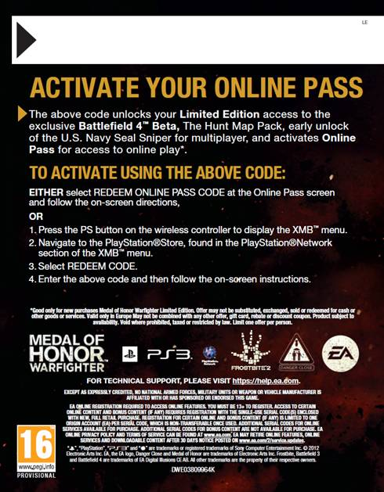

**XBOX 360 instructions:**

**Existing Xbox LIVE**® **members. Sign In to your profile** and follow these steps:

1. Press the **Xbox Guide button** on your controller.

2. Navigate to the **Marketplace** tab.

3. Select **Redeem Code**. Enter your code. Enjoy!

**Not an Xbox LIVE member?** Follow these steps to join Xbox LIVE first:

1. Press the **Xbox Guide button** on your controller.

2. Select **Create Profile**. Follow on-screen instructions to choose your Profile name & avatar.

3. Select **Join Xbox LIVE**. Follow on-screen instructions to setup your Xbox LIVE account.

4. Continue with redemption instructions for **Existing Xbox LIVE Members**.

